Name : Sakshi Mohan Kamble

PRN : 2020BTEIT00205

Course name : Agile software tools and practices Lab

Assignment 11

Title :

Use tools Jenkin tool (trail) version (online(cloud)/offilne ) for demostration of CD/CD of project/miniproject/code

Installation of Jenkins:

**Step 1: Setup wizard**

On opening the Windows Installer, an **Installation Setup Wizard** appears, Click **Next** on the Setup Wizard to start your installation.

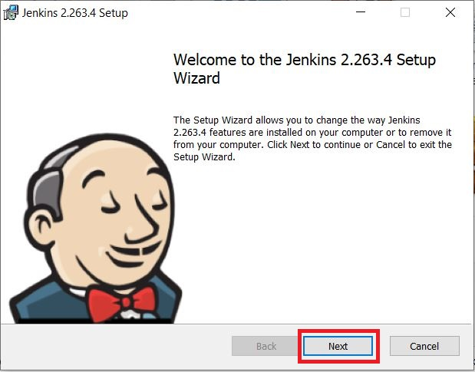

**Step 2: Select destination folder**

Select the destination folder to store your Jenkins Installation and click **Next** to continue

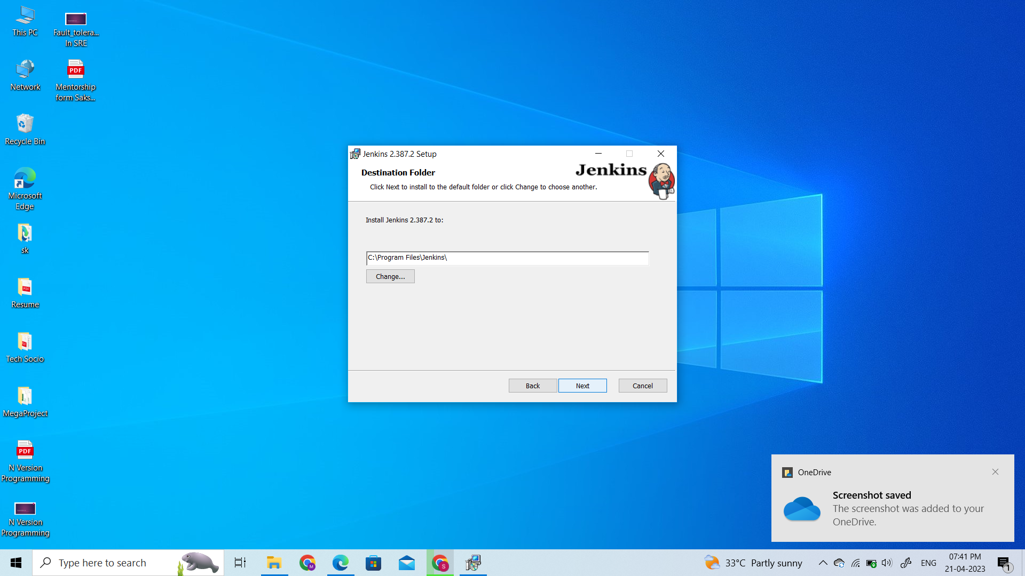

**Step 3: Service login credentials**

When Installing Jenkins, it is recommended to install and run Jenkins as an independent windows service using a **local or domain user** as it is much safer than running Jenkins using **LocalSystem(Windows equivalent of root)** which will grant Jenkins full access to your machine and services.

To run Jenkins service using a **local or domain user**, specify the domain user name and password with which you want to run Jenkins, click on **Test Credentials** to test your domain credentials and click on **Next**.

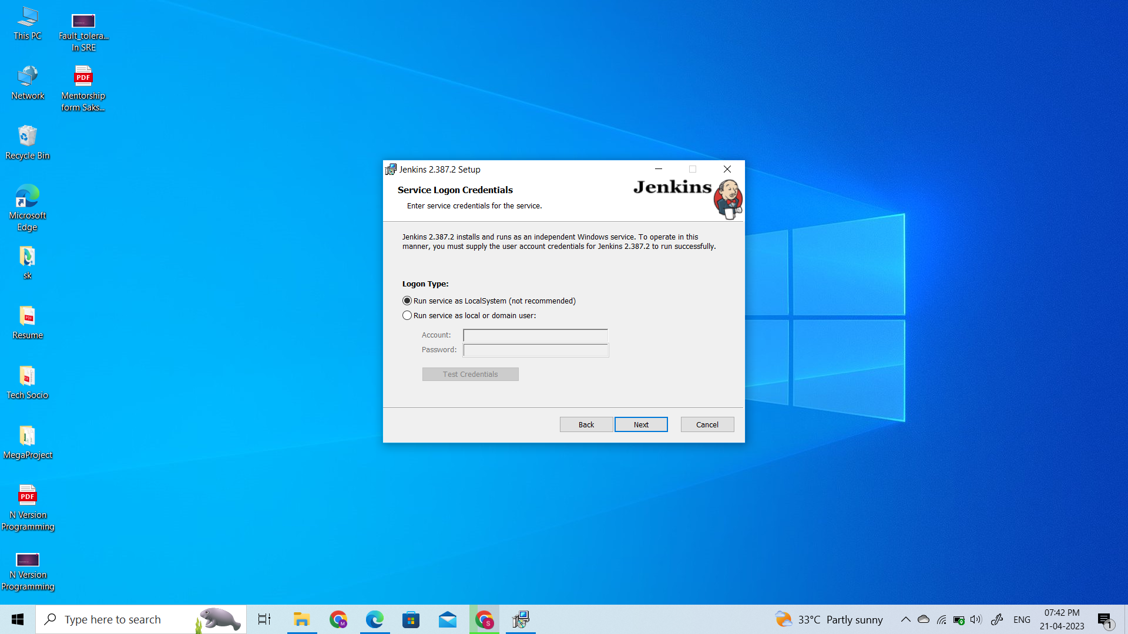

**Step 4: Port selection**

Specify the port on which Jenkins will be running, **Test Port** button to validate whether the specified port if free on your machine or not. Consequently, if the port is free, it will show a green tick mark as shown below, then click on **Next**.

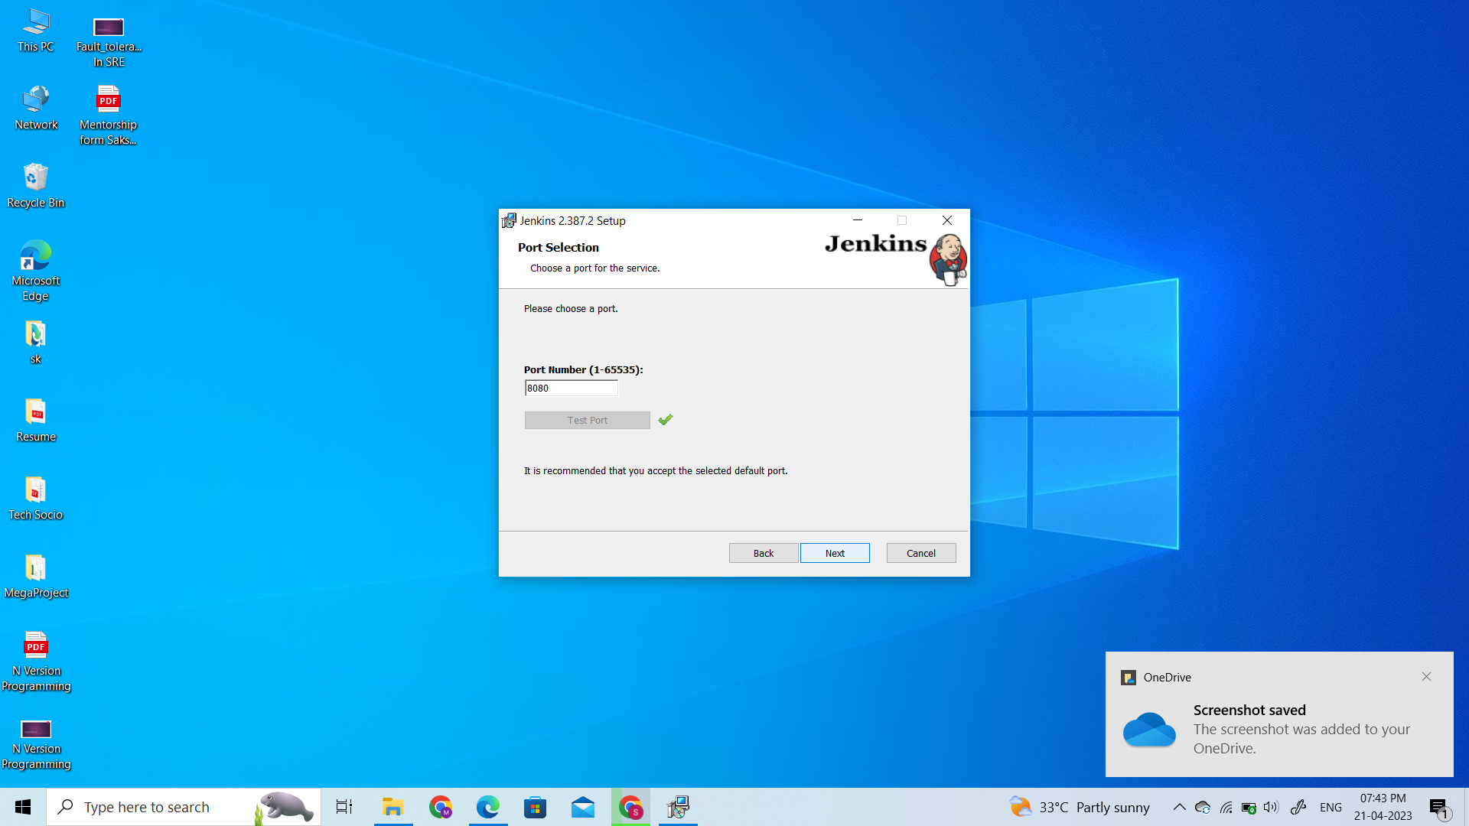

**Step 5: Select Java home directory**

The installation process checks for Java on your machine and prefills the dialog with the Java home directory. If the needed Java version is not installed on your machine, you will be prompted to install it.

Once your Java home directory has been selected, click on **Next** to continue.

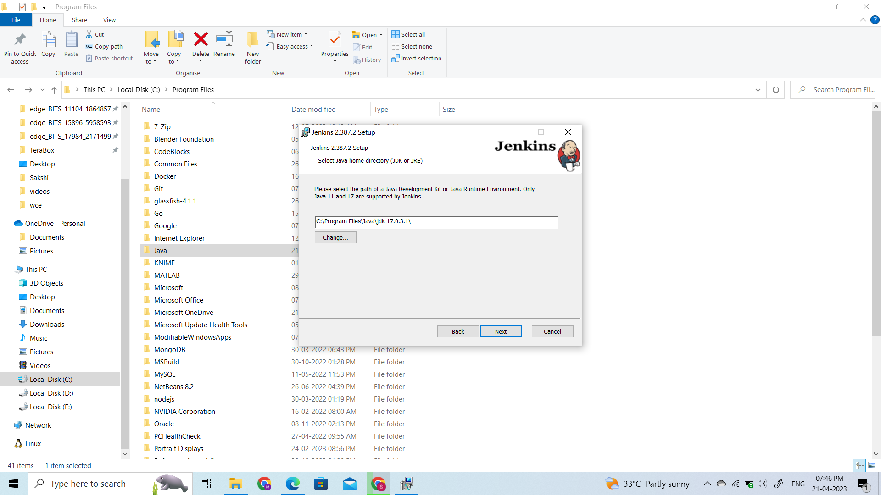

**Step 7: Install Jenkins**

Click on the **Install** button to start the installation of Jenkins.

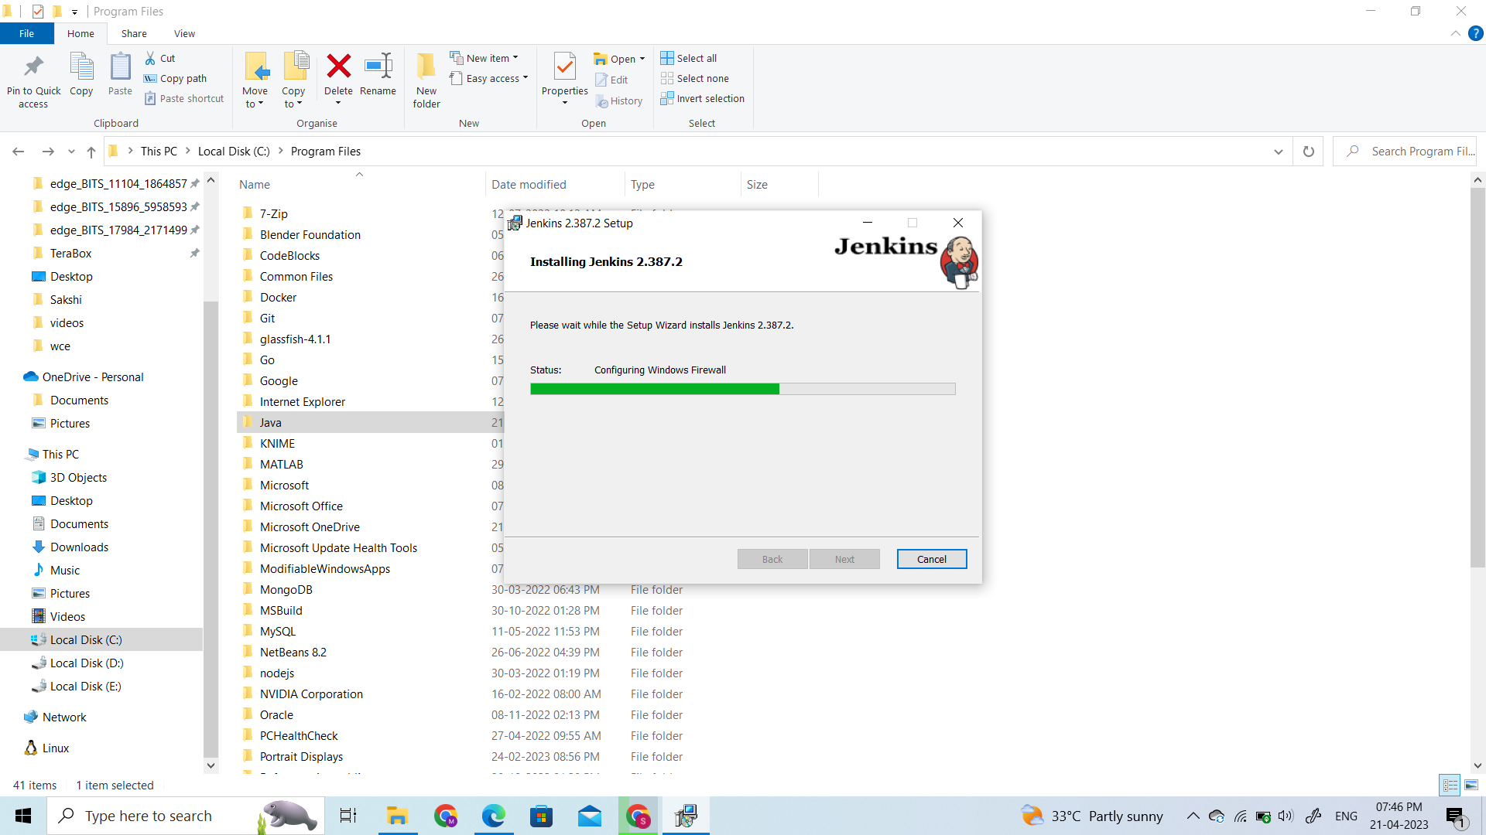

**Step 8: Finish Jenkins installation**

Once the installation completes, click on **Finish** to complete the installation.

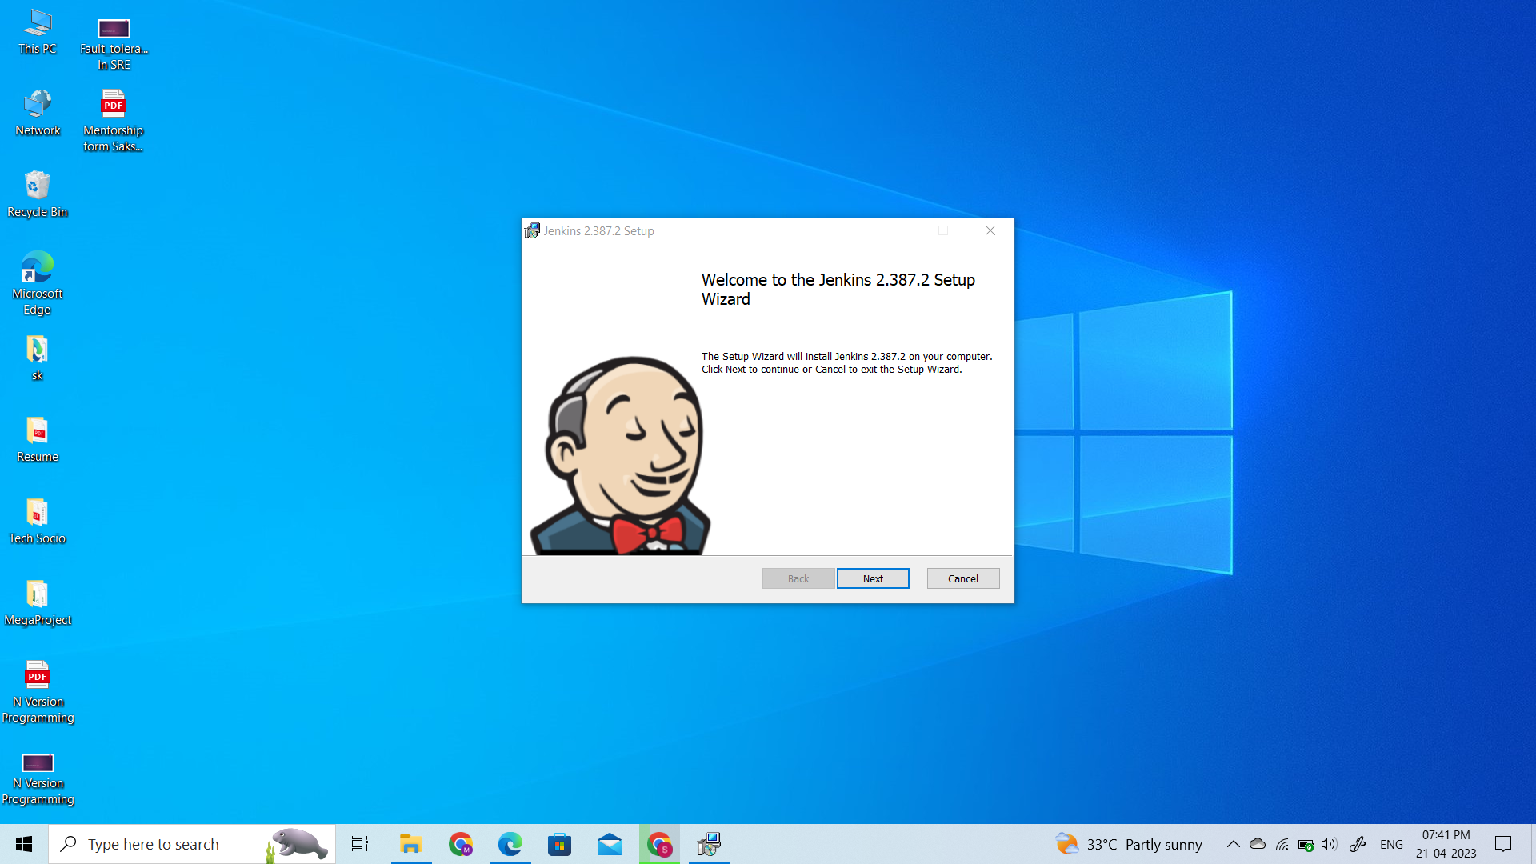

Jenkins will be installed as a **Windows Service**. You can validate this by browsing the **services** section, as shown below:

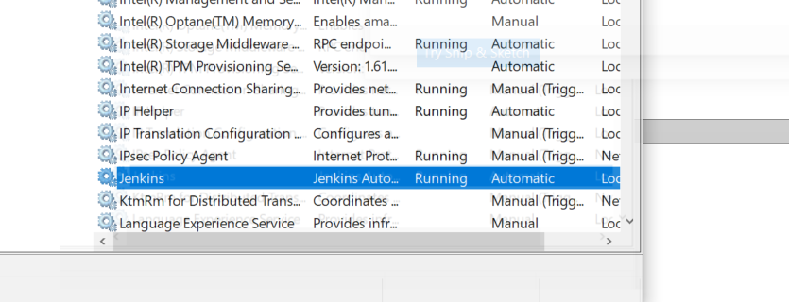

## Post-installation setup wizard

After downloading, installing and running Jenkins, the post-installation setup wizard begins.

This setup wizard takes you through a few quick "one-off" steps to unlock Jenkins, customize it with plugins and create the first administrator user through which you can continue accessing Jenkins.

### Unlocking Jenkins

When you first access a new Jenkins instance, you are asked to unlock it using an automatically-generated password.

**Step 1**

Browse to http://localhost:8080 (or whichever port you configured for Jenkins when installing it) and wait until the **Unlock Jenkins** page appears.

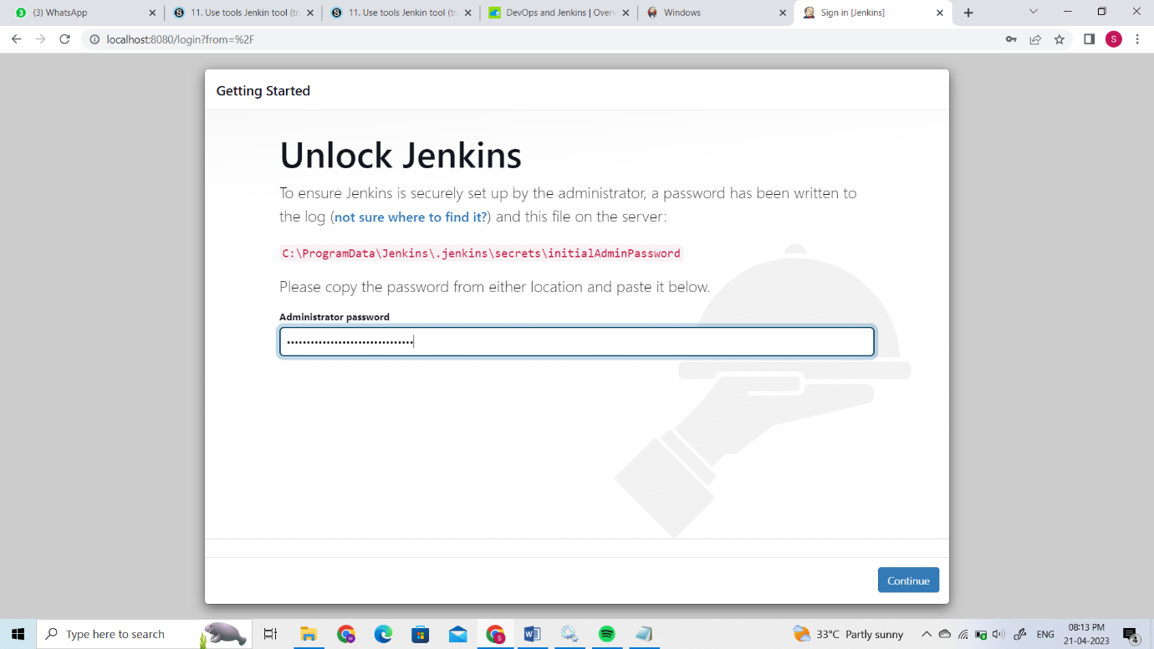

**Step 2**

The initial Administrator password should be found under the Jenkins installation path (set at Step 2 in Jenkins Installation).

For default installation location to C:\Program Files\Jenkins, a file called **initialAdminPassword** can be found under C:\Program Files\Jenkins\secrets.

However, If a custom path for Jenkins installation was selected, then you should check that location for **initialAdminPassword** file.

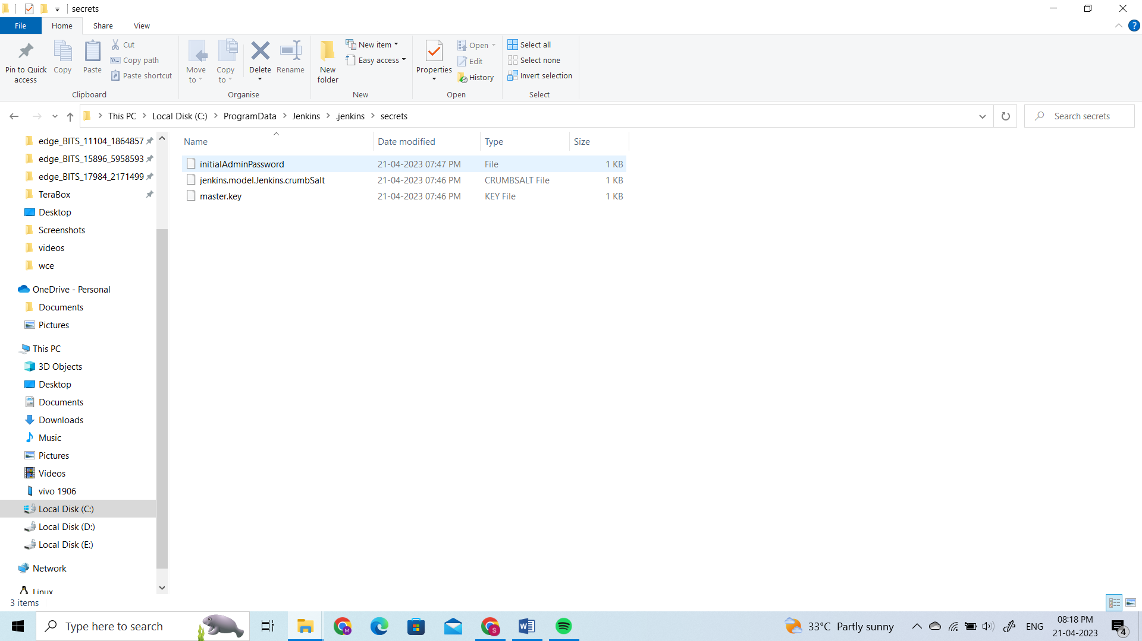

**Step 4**

On the **Unlock Jenkins** page, paste this password into the **Administrator password** field and click **Continue**.



### Customizing Jenkins with plugins

After [unlocking Jenkins](https://www.jenkins.io/doc/book/installing/windows/#unlocking-jenkins), the **Customize Jenkins** page appears. Here you can install any number of useful plugins as part of your initial setup.

Click one of the two options shown:

* **Install suggested plugins** - to install the recommended set of plugins, which are based on most common use cases.
* **Select plugins to install** - to choose which set of plugins to initially install. When you first access the plugin selection page, the suggested plugins are selected by default.

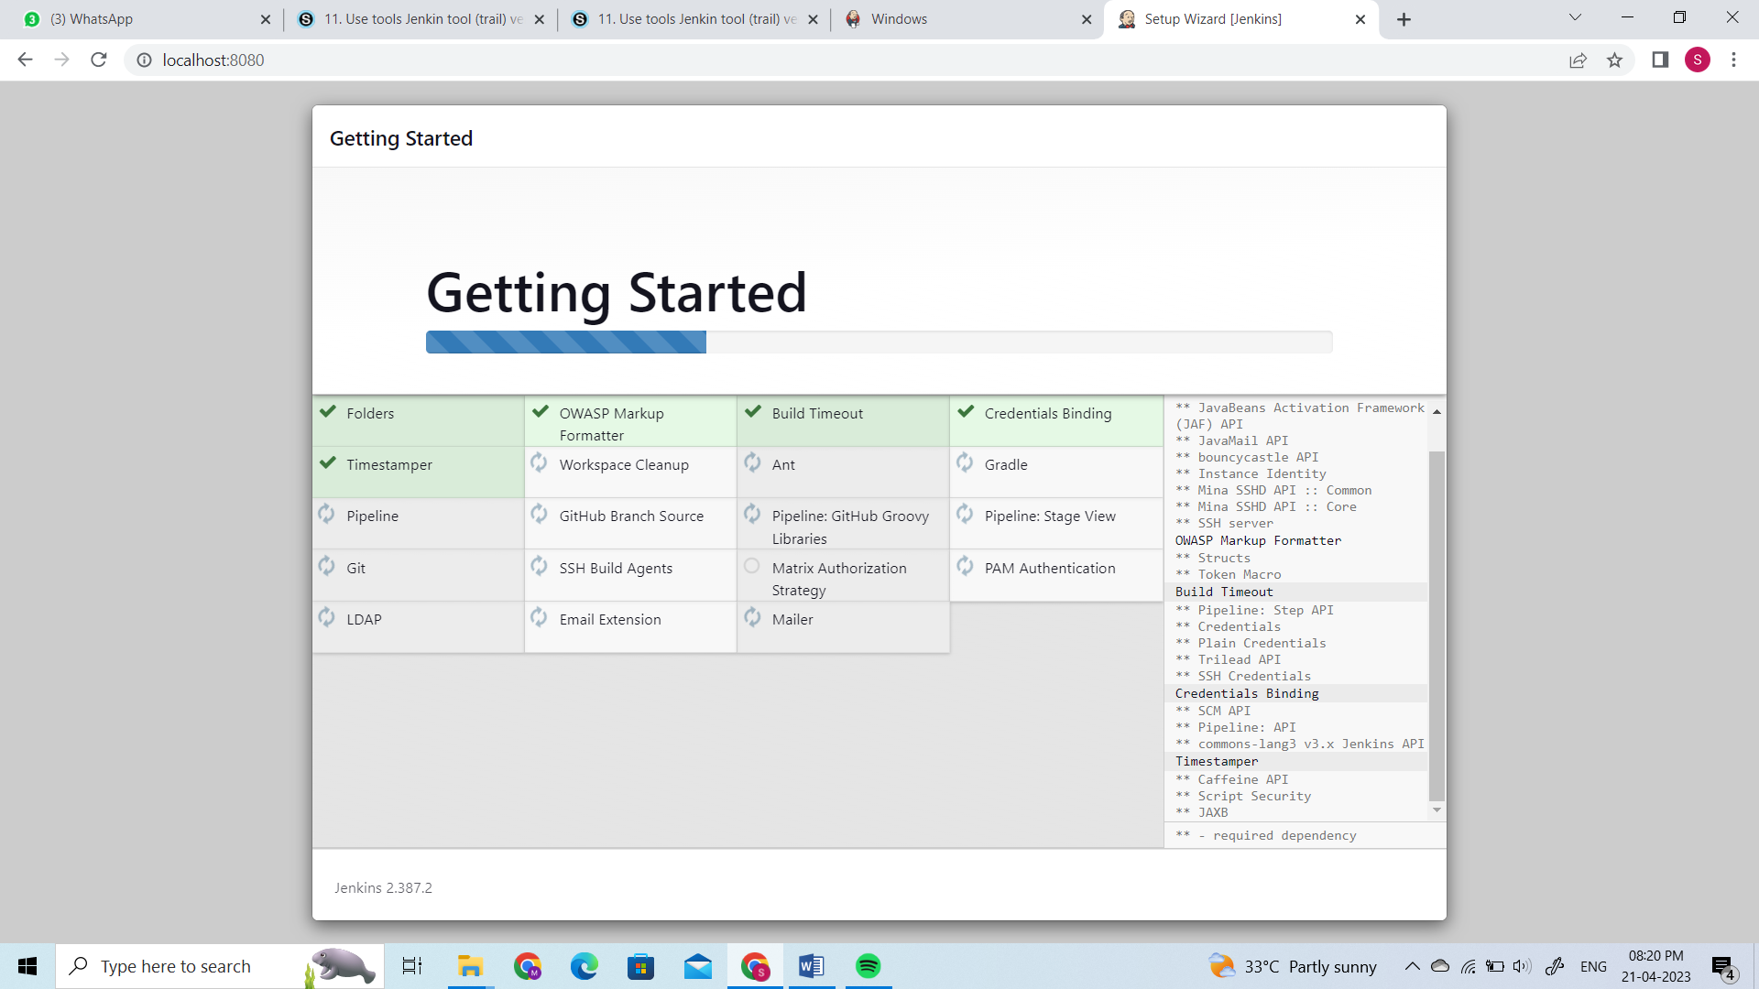

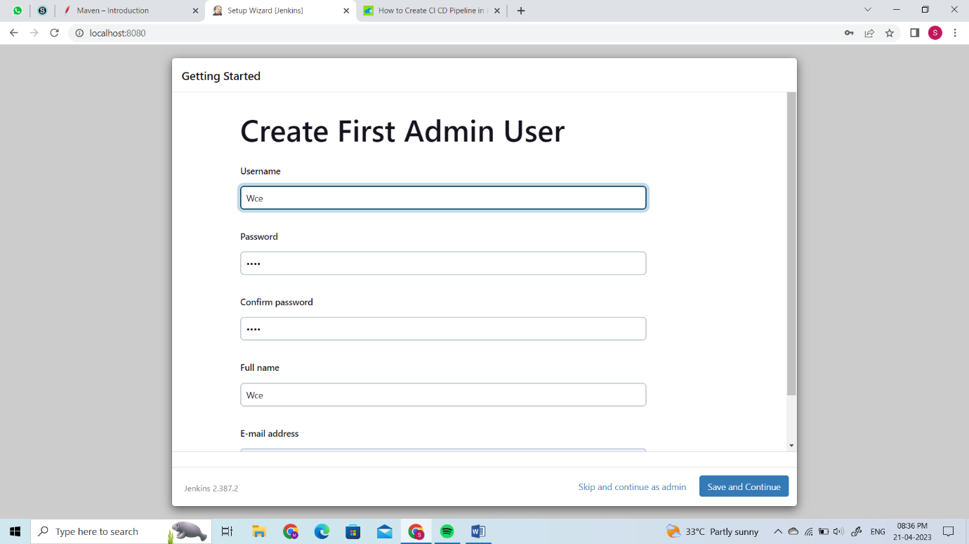

Copy the above location and go back to your Jenkins Dashboard. Look for Global Tool Configuration under the Manage Jenkins menu, as shown in the image below.

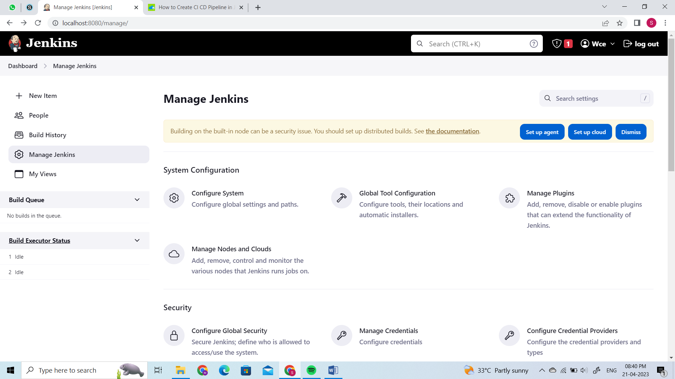

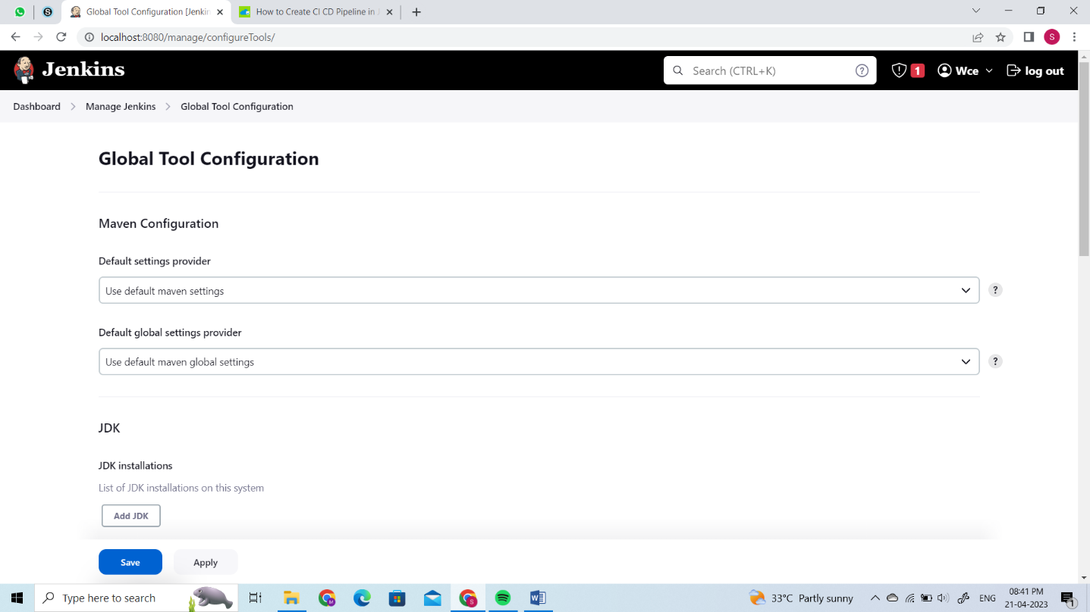

Unselect the Install automatically button from the JDK window and fill the fields. Paste the java location path and trim it as shown in the image below. In the below Git window, select the install automatically checkbox.

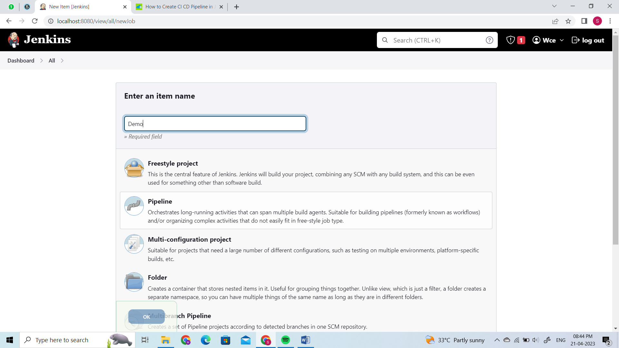

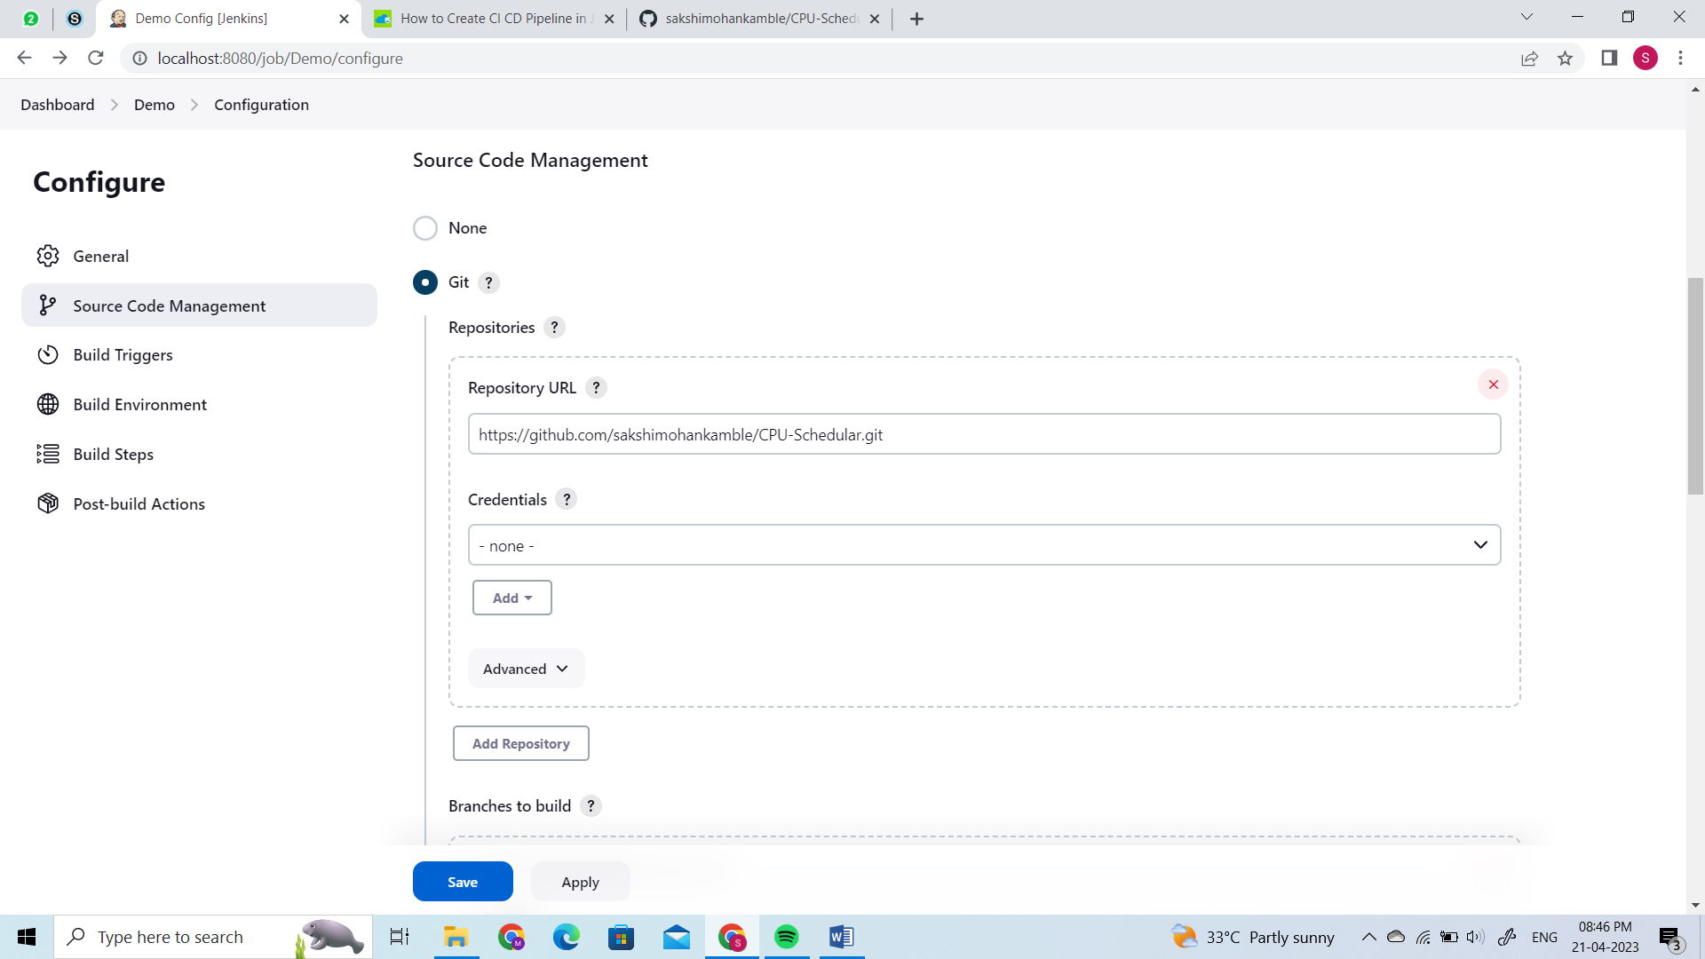

## Conclusion

CI CD Pipelines in DevOps enables an organization in the faster and effective delivery of software products. In this blog, we have created a Virtual Machine in Azure and followed all the steps to create CI CD pipeline using Jenkins. We used Tomcat as our container service and deployed our simple web app via Jenkins.